**AGGREGATE FUNCTION:**

**MAXIMUM**

**> db.employee.aggregate([{$group:{_id :"$address",same_Age: {$max :"$Age"}}}])**



**MINIMUM**

db.varsha.aggregate([{$group:{_id :"$address",min_Age: {$min :"$Age"}}}]



**Sum**

db.varsha.aggregate([{$group:{_id:”$address”,same_age:{$sum:”$age}}}])



**PUSH**

db.varsha.aggregate([{$group:{_id:”$address”,same_age:{$push:”$name”}}}])



**ADD TO SET**

db.varsha.aggregate([{$group:{_id:”$age”,same_address:{$addToSet:”$name”}}}])

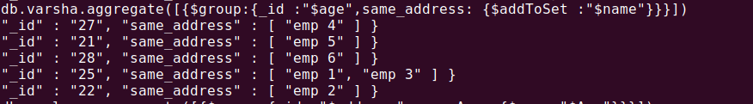

**FIRST**

db.varsha.aggregate([{$group:{_id:”$address”,same_age:{$first:”$age”}}}])

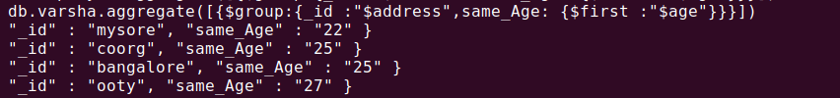

**LAST**

db.varsha.aggregate([{$group:{_id:”$address”,same_age:{$addToSet:”$age”}}}])

